**Practical 04**

**Write the program for the following:**

**a. Create a simple application to demonstrate your vacation using calendar control.**

**Code:**

**WebForm1.aspx :**

<%@ Page Language="C#" AutoEventWireup="true" CodeBehind="WebForm1.aspx.cs" Inherits="pract3B.WebForm1" %>

<!DOCTYPE html>

<html xmlns="http://www.w3.org/1999/xhtml">

<head runat="server">

<title>Vacation Planner</title>

</head>

<body>

<form id="form1" runat="server">

<div>

<h2>Vacation Planner</h2>

<asp:Calendar ID="calendarVacation" runat="server" OnSelectionChanged="calendarVacation_SelectionChanged" OnDayRender="calendarVacation_DayRender" BackColor="White" BorderColor="Black" BorderStyle="Solid" CellSpacing="1" Font-Names="Verdana" Font-Size="9pt" ForeColor="Black" Height="250px" NextPrevFormat="ShortMonth" Width="330px">

<DayHeaderStyle Font-Bold="True" Font-Size="8pt" ForeColor="#333333" Height="8pt" />

<DayStyle BackColor="#CCCCCC" />

<NextPrevStyle Font-Bold="True" Font-Size="8pt" ForeColor="White" />

<OtherMonthDayStyle ForeColor="#999999" />

<SelectedDayStyle BackColor="#333399" ForeColor="White" />

<TitleStyle BackColor="#333399" BorderStyle="Solid" Font-Bold="True" Font-Size="12pt" ForeColor="White" Height="12pt" />

<TodayDayStyle BackColor="#999999" ForeColor="White" />

</asp:Calendar>

<br />

<asp:Label ID="lblSelectedDate" runat="server" Text="Please select your vacation date."></asp:Label>

</div>

</form>

</body>

</html>

**C# code:**

using System;

using System.Web.UI;

using System.Web.UI.WebControls;

namespace pract3B

{

public partial class WebForm1 : Page

{

protected void Page_Load(object sender, EventArgs e)

{

}

protected void calendarVacation_SelectionChanged(object sender, EventArgs e)

{

// Get the selected date from the calendar

DateTime selectedDate = calendarVacation.SelectedDate;

// Check if the selected date is Christmas 2024

if (selectedDate.Year == 2024 && selectedDate.Month == 12 && selectedDate.Day == 25)

{

lblSelectedDate.Text = "You have selected Christmas for your vacation.";

// Select the range of dates for the vacation

calendarVacation.SelectedDate = new DateTime(2024, 12, 25);

calendarVacation.SelectedDates.SelectRange(calendarVacation.SelectedDate, calendarVacation.SelectedDate.AddDays(6));

}

else

{

// Display the selected date in the label

lblSelectedDate.Text = $"You have selected {selectedDate.ToString("D")} for your vacation.";

}

}

protected void calendarVacation_DayRender(object sender, DayRenderEventArgs e)

{

// Check if the day is December 25, 2024

if (e.Day.Date.Year == 2024 && e.Day.Date.Month == 12 && e.Day.Date.Day == 25)

{

Label l = new Label();

l.Text = "<br/>Christmas<br/>Vacation";

e.Cell.Controls.Add(l);

}

}

}

}

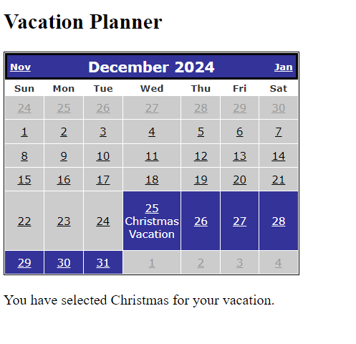**Output:**

**b. Create Web Form to demonstrate use of Adrotator Control.**

**Code**:

**WebForm1.aspx** **:**

<%@ Page Language="C#" AutoEventWireup="true" CodeBehind="WebForm1.aspx.cs" Inherits="pract4B.WebForm1" %>

<!DOCTYPE html>

<html xmlns="http://www.w3.org/1999/xhtml">

<head runat="server">

<title></title>

<style type="text/css">

#form1 {

height: 67px;

}

</style>

</head>

<body>

<form id="form1" runat="server">

<div>

<asp:Label ID="Label1" runat="server" Font-Bold="True" Font-Size="Medium" style="top: 15px; left: 101px; position: absolute; height: 23px; width: 153px" Text="Adrotator Control"></asp:Label>

<br />

<br />

<asp:AdRotator ID="AdRotator1" runat="server" AdvertisementFile="~/XMLFile1.xml" />

</div>

</form>

</body>

</html>

**XML code:**

<?xml version="1.0" encoding="utf-8" ?>

<Advertisements>

<Ad>

<ImageUrl>img.jpg</ImageUrl>

<NavigateUrl>https://google.com</NavigateUrl>

<AlternateText>Broken img</AlternateText>

<Impression>5</Impression>

<Keywords>Nature</Keywords>

</Ad>

<Ad>

<ImageUrl>2.jpg</ImageUrl>

<NavigateUrl>https://youtube.com</NavigateUrl>

<AlternateText>Broken img</AlternateText>

<Impression>2</Impression>

<Keywords>sunset</Keywords>

</Ad>

<Ad>

<ImageUrl>3.jpg</ImageUrl>

<NavigateUrl>https://facebook.com</NavigateUrl>

<AlternateText>Broken img</AlternateText>

<Impression>1</Impression>

<Keywords>flowers</Keywords>

</Ad>

</Advertisements>

Output:

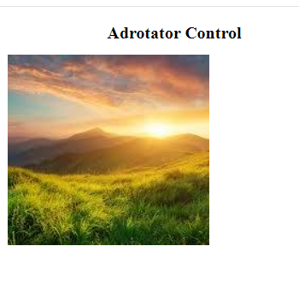 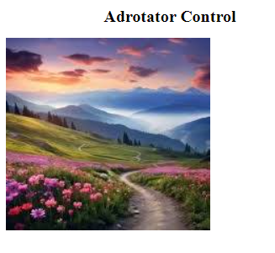

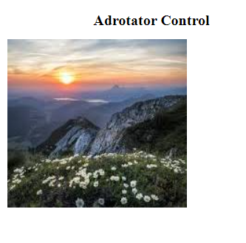

**c. Create Web Form to demonstrate use Multiview control.**

**Code**:

**WebForm.aspx :**

<%@ Page Language="C#" AutoEventWireup="true" CodeBehind="WebForm2.aspx.cs" Inherits="multiview.WebForm2" %>

<!DOCTYPE html>

<html xmlns="http://www.w3.org/1999/xhtml">

<head runat="server">

<title>Survey</title>

</head>

<body>

<form id="form1" runat="server">

<div>

<h2>Simple Survey</h2>

<asp:MultiView ID="MultiView1" runat="server" ActiveViewIndex="0">

<asp:View ID="Step1" runat="server">

<h3>Step 1: Personal Information</h3>

<asp:Label ID="lblName" runat="server" Text="Name: " />

<asp:TextBox ID="txtName" runat="server" />

<br />

<asp:Label ID="lblEmail" runat="server" Text="Email: " />

<asp:TextBox ID="txtEmail" runat="server" />

<br />

<asp:Button ID="btnNext1" runat="server" Text="Next" OnClick="btnNext1_Click" />

</asp:View>

<asp:View ID="Step2" runat="server">

<h3>Step 2: Survey Questions</h3>

<asp:Label ID="lblQuestion1" runat="server" Text="Question 1: How did you hear about us?" />

<asp:TextBox ID="txtQuestion1" runat="server" />

<br />

<asp:Label ID="lblQuestion2" runat="server" Text="Question 2: Rate our service." />

<asp:DropDownList ID="ddlRating" runat="server">

<asp:ListItem Text="Excellent" Value="5" />

<asp:ListItem Text="Good" Value="4" />

<asp:ListItem Text="Average" Value="3" />

<asp:ListItem Text="Below Average" Value="2" />

<asp:ListItem Text="Poor" Value="1" />

</asp:DropDownList>

<br />

<asp:Button ID="btnPrevious1" runat="server" Text="Previous" OnClick="btnPrevious1_Click" />

<asp:Button ID="btnNext2" runat="server" Text="Next" OnClick="btnNext2_Click" />

</asp:View>

<asp:View ID="Step3" runat="server">

<h3>Step 3: Confirmation</h3>

<asp:Label ID="lblConfirm" runat="server" Text="Please confirm your details." />

<br />

<asp:Label ID="lblSummary" runat="server" />

<br />

<asp:Button ID="btnPrevious2" runat="server" Text="Previous" OnClick="btnPrevious2_Click" />

<asp:Button ID="btnSubmit" runat="server" Text="Submit" OnClick="btnSubmit_Click" />

</asp:View>

<asp:View ID="Step4" runat="server">

<h3>Thank You!</h3>

<asp:Label ID="lblThanks" runat="server" Text="Thank you for completing the survey!" />

</asp:View>

</asp:MultiView>

</div>

</form>

</body>

</html>

**C# code:**

using System;

using System.Web.UI;

namespace multiview

{

public partial class WebForm2 : System.Web.UI.Page

{

protected void Page_Load(object sender, EventArgs e)

{

}

protected void btnNext1_Click(object sender, EventArgs e)

{

MultiView1.ActiveViewIndex = 1;

}

protected void btnNext2_Click(object sender, EventArgs e)

{

lblSummary.Text = "Name: " + txtName.Text + "<br />Email: " + txtEmail.Text + "<br />" +

"Question 1: " + txtQuestion1.Text + "<br />Rating: " + ddlRating.SelectedItem.Text;

MultiView1.ActiveViewIndex = 2;

}

protected void btnPrevious1_Click(object sender, EventArgs e)

{

MultiView1.ActiveViewIndex = 0;

}

protected void btnPrevious2_Click(object sender, EventArgs e)

{

MultiView1.ActiveViewIndex = 1;

}

protected void btnSubmit_Click(object sender, EventArgs e)

{

MultiView1.ActiveViewIndex = 3;

}

}

}

Output:

